NEW EXECUTIVE GLASS DESK NAMEPLATES
CUSTOM MADE AT LOW DISCOUNT PRICES!
Now You Can Have Beautiful Personalized Executive Glass Nameplates,
Custom Made At Prices That Are Very Competitive With Cheap Acrylic
Engraved Nameplates. Here Is A Great Desk Accessory To Give Your
Employees, Your Good Customers And Even Yourself!
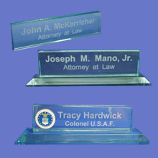  1/2" Thick 2"x 6" And 2"x 8" Nameplates. | Here is Your Choice of Exquisite Personalized Etched Heavyweight Jade Glass Desk Nameplates that are Cut and Polished to Sparkling Perfection and then Custom Etched with Your Names to make the Absolutely Perfect Executive Gift that Adds Elegance to any Desktop. These Glass Nameplates are Great Gifts for Your Office Personnel to say "Thank You" for a job well done or to give to your Customers to simply say "We Really Appreciate Your Business". Anyway you use them will bring Your Company Real Appreciation for such a Unique and Thoughtful Gift and it will add a Lasting Impression of Good Taste to any Executive Desk.

HEAVYWEIGHT 3/4" THICK PREMIUM NAMEPLATES
Nameplate Prices Including Your Name Etched In Your Type Style.
*For Company Logo's Add $25.00 One Time Charge. (With Company Supplying The Logo Copy)

Without Base
- 2" x 6" x 1/2" Thick = $19.95
- 2" x 8" x 1/2" Thick = $24.95
- 2" x 8" x 3/4" Thick = $29.95
- 2”x 10”x 3/4” Thick = $39.95
- 2-1/2”x 10”x 3/4” Thick = $44.95
- 2-1/2”x 12”x ¾” Thick = $49.95

With Base
- 2" x 8" x 3/4" Thick = $39.95
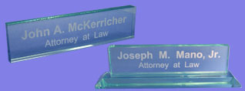
- 2-1/2”x 12”x 3/4” Thick = $54.95
You Select The Type Font From Our List And We Do The Rest.
*NOTE: For Company Logo's There Is A Slight Extra Charge.

Mail, FAX, Call or email Your Order To:

Orders Usually Shipped or Delivered Within 3-5 Days After Artwork Approved.

